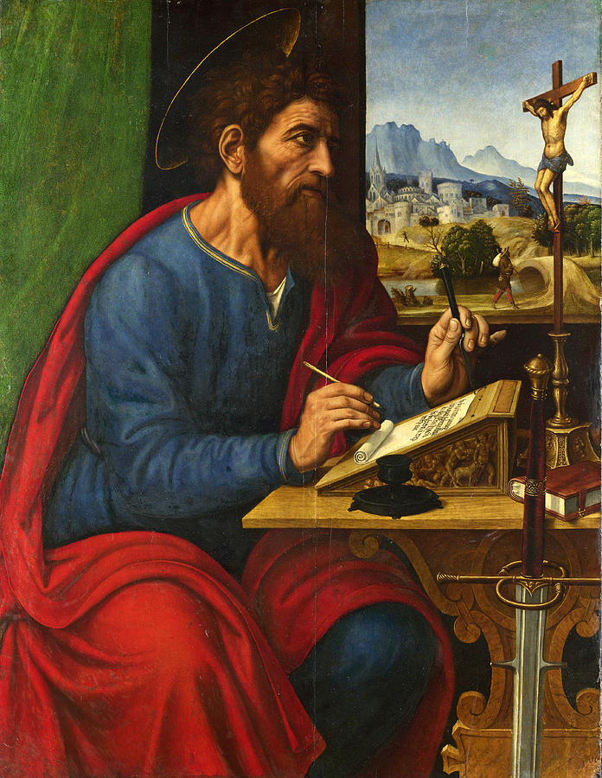
Romans 1:1-7 study
Let us pray: We thank you Christ, new life is ours, new life, new hope, new strength, new powers. This grace our every way attend, until we reach our journey’s end, Amen. (LSB 562.6).
Text: Paul, slave of Christ Jesus, called apostle, set apart for the Gospel of God, 2) which He promised beforehand through the prophets in Holy Scripture, 3) concerning His Son, who came to be out of David’s seed according to the flesh 4) and was marked out with power according to the Holy Spirit (Spirit of Holiness) by His resurrection from the dead, Jesus Christ our Lord. 5)Through Whom we received grace and apostleship to bring about (a. obedience which springs from faith, b. obedience to faith, c. obedience which consists in faith) for the sake of His Name in all the nations, 6) among you also you who are called of Jesus Christ 7) to all who are in Rome, who are loved by God, called to be saints, grace to you and peace from God our Father and the Lord Jesus Christ. (Read 3x)

- What does it mean that St. Paul is a “slave of Christ,” and what does this mean for us as well? Read Philemon 1:1; Titus 1:1; James 1:1; 2nd Peter 1:1; Jude 1; John 8:34-36. ________________________________________________________________________________________________________________________________________________________________________________________________________________________________________________________________________________________________________________________________________________________________________________________________________________________________________________________________________________________________________________________________________________________________________________________________________________________________________________
- Why does St. Paul emphasize his apostleship? How does verse 5 help define The apostolic vocation? Read John 20:19-23; 2nd Corinthians 5:18-21; Matthew 28:16-20; Ephesians 2:8-10. __________________________________________________________________________________________________________________________________________________________________________________________________________________________________________________________________________________________________________________________________________________________________________________________________________________________________________________________________________________________________________________________________________________________________
- How do verses 3-4 help us understand who Jesus is, both as man and God? Also, why does St. Paul emphasize the resurrection and not mention the cross? ________________________________________________________________________________________________________________________________________________________________________________________________________________________________________________________________________________________________________________________________________________________________________________________________________________________________________________________________________________________________________________________________________________________________________________________________________________________________________________________________________________________________________________________________________________________________________________________________________________________________________________________________________________________________________________________________________________________________________
- What does it mean to be a saint? ____________________________________________________________________________________________________________________________________________________________________________________________________________________________________________________________________________________________________________________________________________________________________________________________________________________________________________________________________________________________________________________________________________________________________________________________________________________________________________________________________________________________________________________________________________________________________________________________________________

